COVALENT BONDING

In covalent bonding non-metal atoms share one or more pairs of electrons by overlapping their outer shells to give each the noble gas structure. The nuclei of the atoms are attracted to the electrons between them and this is the covalent bonding. The resulting species is a MOLECULE.

Definition: A covalent bond is a shared pair of electrons. There is a force of attraction between the bonding pair of electrons and the nuclei of the atoms at each side.

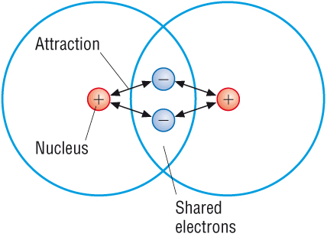
Hydrogen atoms only need two electrons in their outer level to reach the noble gas structure of helium. Once again, the covalent bond holds the two atoms together because the pair of shared electrons is attracted to both nuclei.

Unpaired electrons pair up.

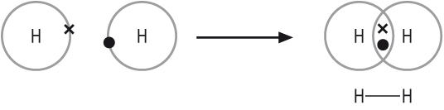

Complete the following text by inserting keywords from the list below:

Six; electrons; noble; eight; periodic; atoms;

It was the US chemist Gilbert Lewis who first suggested the octet rule in 1916. The rule says

that atoms gain, lose or share ______________ when they combine with other _________

to acquire a stable octet of electrons. The “stable octet” is the ___________electrons

corresponding to the outer electron configuration of the nearest _______________ gas in the

___________________ table.

There are many exceptions to the octet rule. An example is molecule of BCl₃. There are only

___________ electrons round central boron atom. Other example is SF₆ , a molecule with

more than eight electrons in the outer shell of the central atom.

Exersice 1 Complete the table

Element | Molecular formula | Displayed formula | Dot-and-cross diagram
Chlorine | Cl₂ | Cl – Cl | 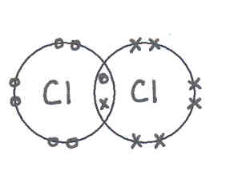
Hydrogen chloride

Oxygen

Water
Methane

Carbon dioxide

Ethane | C₂H₆
Ethene | C₂H₄
Methanol | CH₃OH
Nitrogen | N₂
Hydrogen cyanide | HCN
Ammonia

Boron trifluoride

Sulfur hexafluoride

Background Reading

Gilbert Newton Lewis was probably the greatest and most influential of American chemists. Through the nineteenth century, Europe dominated science, but the first half of the twentieth century brought a tidal wave of scientific research that thrust America to the forefront. Lewis influenced this revolution by both his teaching and his research. During his career he published over 150 papers.

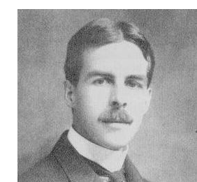

Gilbert Newton Lewis was born at Weymouth, Massachusetts, on October 23, 1875. He was educated at home by his parents in the style of the English tutoring system. His only public schooling occurred between the ages of 9 to 14 years in Lincoln, Nebraska. At age fourteen, Lewis entered the University of Nebraska but transferred to Harvard College after three years. In 1899 he was awarded his PhD at age 24 under the supervision of T.W. Richards.
G. N. Lewis (1875-1946) created the College of Chemistry at the University of California, Berkeley, and made it into one of the world’s most productive centres of chemistry research. His other works included acid-base theory, the electron-pair bonding theory of atoms and molecules, the thermodynamics of solutions, the first isolation of heavy water (D₂O), and the phosphorescence and magnetic properties of molecules.
Lewis continued with his research until his death on March 23, 1946, in his laboratory surrounded by his beakers and test tubes. There is no scientist in American history who has contributed more extensively to all fields in chemistry than Gilbert Newton Lewis. His thinking was far ahead of his time and his theories have had profound influence on modern chemistry. Although Lewis was never to receive the Nobel Prize, it is commonly felt that his work in thermodynamics and valence theory more than merited this award.
To be able to answer following questions you should do additional independent reading.
1. A Lewis acid is defined as “an electron pair acceptor”. Give another definition of acid.

2. What is heavy water?

3. Which of noble gases does not have “Lewis octet”? How many electrons does this noble gas have in its outer shell?

SHAPES OF MOLECULES

The electron pair repulsion theory

- The four pairs of electrons around a central atom repel each other.

- Pairs of electrons arrange themselves so they are as far apart as possible.

- The repulsion between lone pairs is greater than the repulsion between bonding pairs.

Exercise 5
For each of the molecules below
- draw its “dot-and-cross” diagram
- sketch its shape
- give the name of the shape
- show its bond angles

Molecule | “Dot-and-cross” diagram | Shape | Name of the shape | Bond angle
CH₄

NH₃

H₂O

BCl₃

CO₂

SF₆

NH₄⁺

Exercise 6

1. (a) State what is meant by a term dative covalent bond.

[2]

Ammonia reacts with hydrogen chloride to give the salt ammonium chloride. This contains ammonium ions, NH₄⁺, and chloride ions, Cl⁻. In the ammonium ion, a lone pair of electrons from ammonia forms a dative covalent bond to the hydrogen ion, H⁺, from the hydrogen chloride.

(b) Write a balanced chemical equation for the reaction between ammonia and hydrogen chloride.

[1]
(c) Draw a dot and cross diagram for:
(i) ammonia, NH₃ (ii) the ammonium ion, NH₄⁺

[3]

- Describe and explain the change in shape when the ammonia molecule becomes the ammonium ion.

[4]

e) Explain why the chloride ion, Cl⁻, is a stable ion.

[1]

Exercise 7

Shapes of molecules
This exercise is aimed at testing your understanding about the shapes of simple molecules and ions. The first example has been completed for you to show you what to do.

Molecule or ion | Number of pairs of electrons around central atom | Number of bonding pairs | Number of lone pairs | Shape | Bond angle
H₂O | 4 | 2 | 2 | non-linear | 104.5º
SiH₄
PF₃
SCl₂
BBr₃
BeCl₂
PCl₆⁻
NH₄⁺
H₃O⁺
SO₂

A SPECTRUM OF BONDING

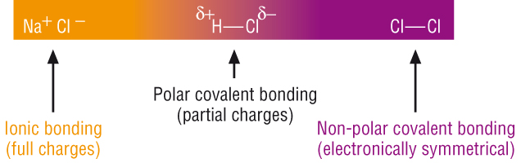

Electronegativity

Ionic character in covalent bonds

- List three typical physical properties of covalent compounds:

1.

2.

3

- Explain what is meant by term ionic bond:

- List and explain three typical physical properties of ionic compounds:

1.

2.

3

Definition: Electronegativity is the ability of an atom to attract the bonding electrons in covalent bond.

Cl
3.0
S
2.5
P
2.1
Si
1.8
Al
1.5
Mg
1.2
Na
0.9
F
4.0
O
3.5
N
3.0
C
2.5
B
2.0
Be
1.5
Li
1.0

The Pauling electronegativity index

? What is the trend in electronegativity from left to right across a period?

What is the trend in electronegativity down a group?

Exercise 8
Why do the noble gases not have electronegativities?

Non- polar bonds
Bonding electrons are shared equally between atoms that have the same electronegativity values
Cl - Cl
3.0 3.0

Polar bonds
A difference in electronegativity results in unequal sharing of bonding electrons and a permanent dipole

δ+ δ-
Definition: A permanent dipole is a small charge difference across a bond that results from a difference in the electronegativities of the bonded atoms

H - Cl
2.1 3.0
Slight positive charge
Slight negative
charge

The greater the difference in electronegativity between the bonded atoms, the greater the permanent dipole. The atom with higher electronegativity will have the δ- charge.

Exercise 9

a) Mark the dipoles on the following molecules

b) Comment on overall polarity of each molecule.

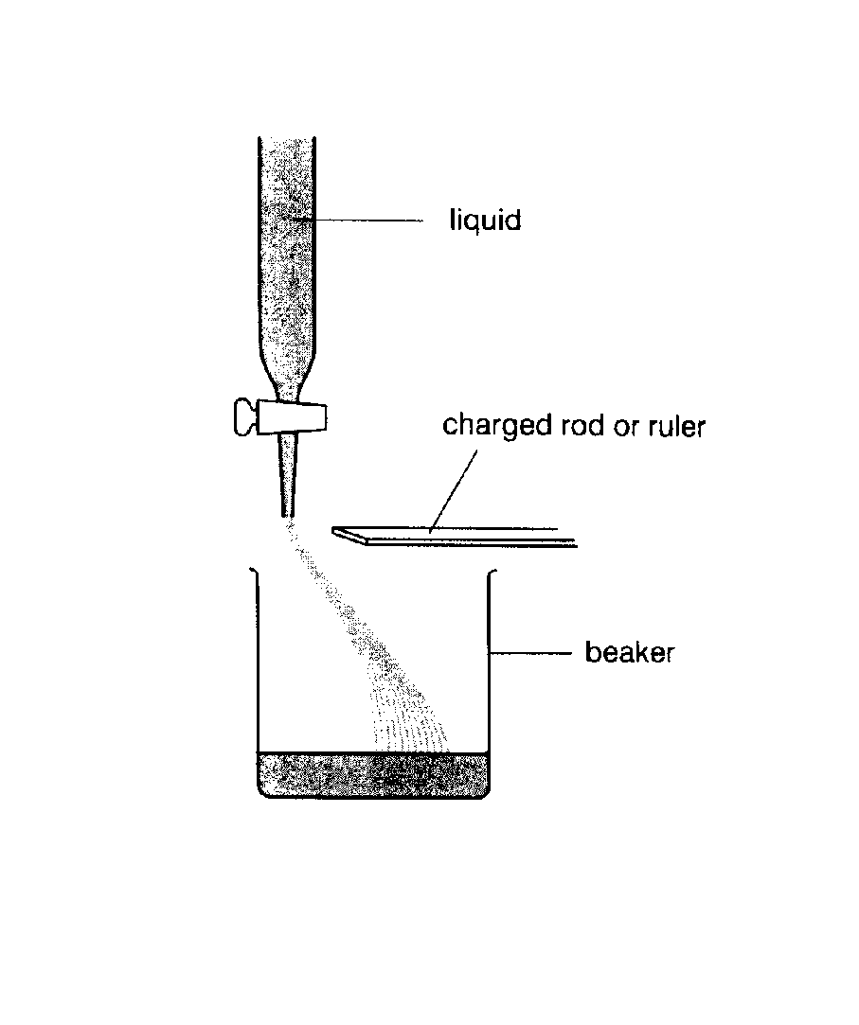
Experiment (demonstration):

Bending jets of liquid

If the molecules in a liquid are polar they should be attracted towards an electrically charged rod

Liquid | Formula | Effect on rod | Does the molecule have permanent dipole?
Water

Ethanol

Cyclohexane

Propanone

Questions

- Mark the uneven charge distribution on the displayed formulae of the molecules.

- The rod is positively charged – why are molecules never repelled by the rod?

Physical properties of covalent compounds

Most covalent compounds:

- have low melting points

- dissolve in non-polar solvents

- do not conduct electricity

Exercise 10 (small groups exercise)
In groups discuss the following questions and suggest the answers.

- Why do most covalent compounds have low melting points?

- Name a covalent compound with a high melting point?

- Covalent compounds often dissolve better in non-polar solvents than in water.
Give an example of a non-polar solvent.

- Name a covalent compound that dissolves in water.

- Name a covalently bonded substance which can conduct electricity.

Extension (will not be assessed): Dative covalent bond (co-ordinate bond)

The pairs of electrons not involved in bonding are called lone pairs or non-bonding pairs.
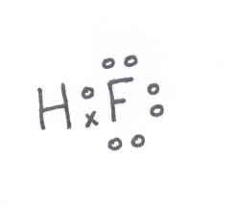
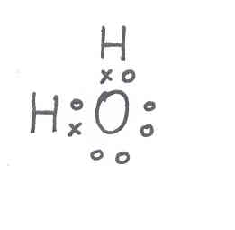
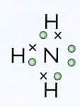

Ammonia
Hydrogen fluoride
Three lone pairs
Water
Two lone pairs
Ammonium
One lone pair

Other species contain atoms that still have not achieved noble gas structure. These are known as electron deficient compounds.

See the following exercise for the example of an electron-deficient compound.

Exercise 2
Draw a dot-cross diagram for BF₃

Have the F atoms achieved a noble gas electron configuration?

Has the B atom?

A lone pair from one atom can be shared with an electron deficient species. This is called a co-ordinate or a dative covalent bond. It is still a share of two electrons so once the bond is formed it is indistinguishable from a covalent bond. The arrow symbol for a co-ordinate bond always points from the donor atom.

Definition: A co-ordinate or a dative covalent bond is a shared pair of electrons which has been provided by one of the bonding atoms only.

Example – formation of the ammonium ion

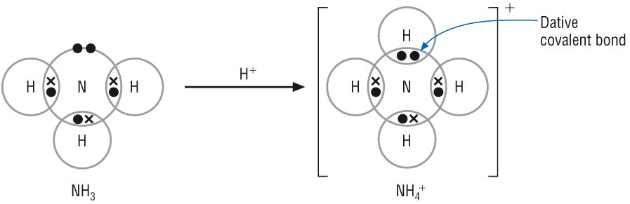

Ammonium ion
Ammonia molecule

Exercise 3

An hydronium ion has the formula H₃O⁺; it is formed when a water molecule forms a dative bond to a H⁺ ion. Draw a dot-cross diagram to illustrate the bonding in this species.

Exercise 4

Suggest a structure for the compound formed when ammonia reacts with boron trifluoride.

Jan 04 Q2
11111111111111111111111

Jan 06 Q2

Jun 04 Q 5
3. In this question, one mark is available for the quality of written communication.

(a) Describe intermolecular forces in CH₄ and in H₂O. [6]
Use clear diagrams in your answer.

(b) State and explain two anomalous properties of H₂O that depend on its intermolecular forces.
[4]

_________________________________________________________________________________

_________________________________________________________________________________

_________________________________________________________________________________

_________________________________________________________________________________

_________________________________________________________________________________

_________________________________________________________________________________

_________________________________________________________________________________

_________________________________________________________________________________

_________________________________________________________________________________

_________________________________________________________________________________

_________________________________________________________________________________

_________________________________________________________________________________

_________________________________________________________________________________

_________________________________________________________________________________

_________________________________________________________________________________

_________________________________________________________________________________

Quality of Written Communication [1]

Total [11]

Jun 05 Q 5
4

Total [7]

6 In this question, one mark is available for the quality of written communication.

Explain how you can predict the shape of, and bond angle in, simple molecules. In your answer, you should choose four different molecular shapes.

___________________________________________________________________________

___________________________________________________________________________

___________________________________________________________________________

___________________________________________________________________________

___________________________________________________________________________

___________________________________________________________________________

___________________________________________________________________________

___________________________________________________________________________

___________________________________________________________________________

___________________________________________________________________________

___________________________________________________________________________

___________________________________________________________________________

___________________________________________________________________________

___________________________________________________________________________

___________________________________________________________________________

___________________________________________________________________________

____________________________________________________________________________

____________________________________________________________________________

____________________________________________________________________________
____________________________________________________________________________

____________________________________________________________________________

____________________________________________________________________________

____________________________________________________________________________

________________________________________________________________________ [10]
Quality of Written Communication [1]
Total [11]

Homework exercise.

For each of the molecules below
- draw its “dot-and-cross” diagram
- sketch its shape
- give the name of the shape
- show its bond angles

SiCl₄; PCl₃; GeCl₄; POCl₃; AlCl₃; BeF₂; H₃O⁺; SO₂; BeCl₂

Notes

Additional resources

Starter exercise

Intermolecular forces
This worksheet is about testing your knowledge about intermolecular forces. Complete the paragraph by inserting keywords from the list below:
van der Waals’ | dipole-dipole | hydrogen bond | polarity
boiling point | electrons | dipole | lone pairs
electronegativity | increase | weak | oxygen
temporary | greater | electrons | induces

When atoms of the same element join together to form molecules there is no difference in electronegativity between atoms. Those small molecules have __________________, fluctuating dipoles due to random movement of _________________. Temporary dipole ____________ dipole on other molecule. This creates intermolecular forces called_____________________. The larger the molecule- greater number of electrons, so ____________________________ van der Waals’ forces between molecules.
When different atoms join together to form molecules there is usually a difference in __________________ between the atoms. This causes an unequal sharing of electrons between the atoms which is called ______________ and results in a separation out of charge called a __________________. Such molecules can attract one another with ______________ forces acting between their molecules.
The strongest of all intermolecular forces is the ______________. This occurs when a hydrogen atom is bonded to a very electronegative atom with ______________ of electrons, like fluorine, ______________ or nitrogen. This intermolecular force occurs in molecules like water and results in their ______________ being much higher than expected for such a relatively small molecule.

Stretch and challenge

A crystal of aluminium chloride vaporises when heated to a relatively low temperature. In the gas phase, aluminium chloride exists as a mixture of AlCl₃ and Al₂Cl₆ molecules. The Al₂Cl₆ molecule is formed when AlCl₃ molecules are linked by two dative (co-ordinate) bonds. The structure of Al₂Cl₆ is shown below with one of the dative bonds labelled.

Cl Cl Cl
Al Al
Cl Cl Cl

dative bond

(a) Explain the meaning of the term dative bond.

(b) Copy the diagram of the molecule and, using an arrow, indicate on the diagram the position of the other dative bond.

(c) Give the bond angles in AlCl₃ and Al₂Cl₆.

